Crystal chemistry
Did you know?
About X-ray crystallography
This is a very powerful method for finding out how particles are arranged inside crystals. In an X-ray crystallography machine a crystal is held in place between a screen and an object which gives out X-rays.
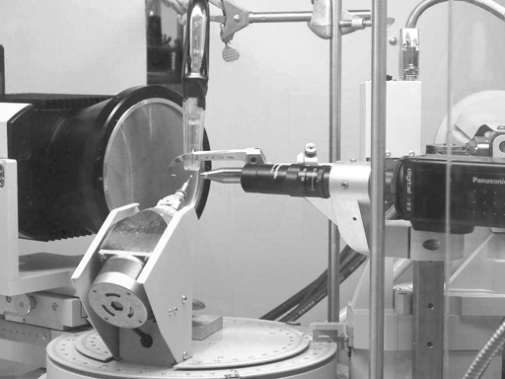 | 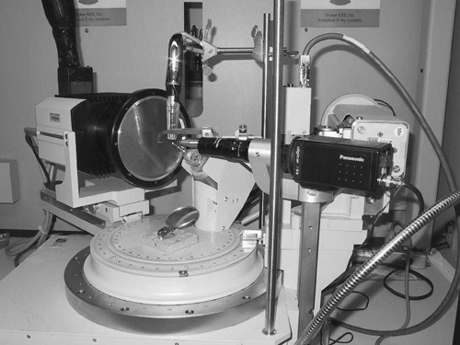
Single crystal X-ray diffractometer
(Reproduced with kind permission from Dr. Maren Pink, Indiana University Molecular Structure Center.)
When the X-ray beam is turned on, X-rays hit the crystal. A pattern of spots is made on the screen at the other side. The pattern shows where the X-rays hit particles inside the crystal. This is called a diffraction pattern. Some spots are darker than others. Very complicated mathematics called Fourier transformation is done using a computer to change the spot pattern into a picture showing how the particles in the crystal are arranged. A father and son team, both called William Bragg, invented X-ray crystallography in 1912 (to tell them apart, their second names are used the father was called William Henry and the son William Lawrence). At the time, all the calculations were done by hand so not surprisingly they won a Nobel prize in 1915 for their hard work. The method has been used to solve the structures of many important molecules. In the 1950s Francis Crick and James Watson used pictures of DNA taken by Rosalind Franklin to solve the DNA structure. Dorothy Hodgkin worked out the structures of the antibiotic penicillin (in 1946), vitamin B12 (in 1956) and insulin (in 1969), winning a Nobel prize in 1964. Now, crystallographers work on molecules the inventors had not even heard of!



